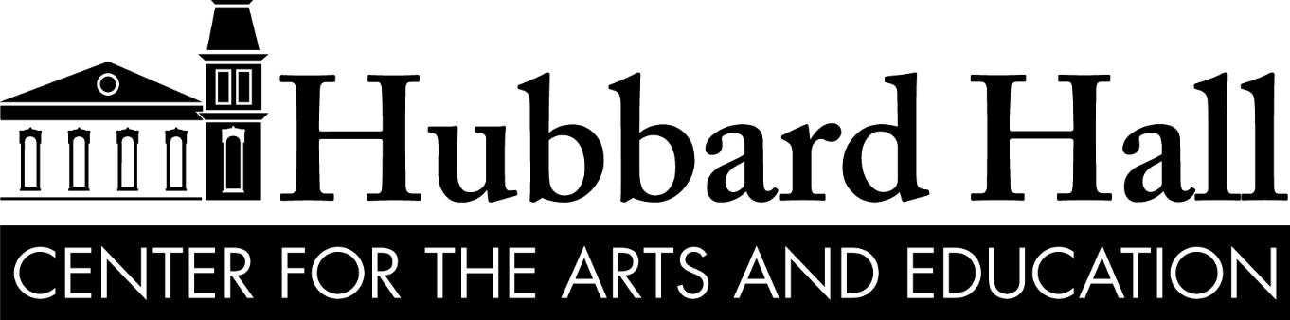

Music, Theater, Opera, Dance, Visual Arts, Classes and Workshops for Learners of All Ages
25 East Main St. Cambridge, NY 12816 (518) 677-2495 www.hubbardhall.org

ABOUT HUBBARD HALL
Hubbard Hall is a thriving arts center dedicated to cultivating, sustaining, and promoting the cultural life of our rural community in Washington County, NY and throughout the Capital Region. We gather people from all walks of life to create, learn, and grow together, while developing, producing, and presenting world-class art and artists. We are an arts incubator, a training ground, a magnet for artistic activity, a safe haven for risk-taking, an economic driver for our region, and the beating heart of our community.

PRODUCTIONS AND PRESENTATIONS: Theater, Music, Opera, Dance, and the Visual Arts
Since 1878 Hubbard Hall has developed, produced, and presented theater, music, dance, and the visual arts, and in recent years has become a world-class development center for new work. Since 1977, Hubbard Hall’s current nonprofit has engaged thousands of artists, students, and audience members in acclaimed productions of theater, opera, music, and dance.

FACILITIES
Hubbard Hall operates four buildings across our campus, including the original 1878 opera house and three recently renovated freight yard buildings containing dance, music and visual arts studios, offices, arts exhibit spaces, and a black box theater. We also own and operate the Cambridge Community Garden, a collaborative garden managed entirely by volunteers and engaging hundreds of students each year with opportunities to grow and harvest their own vegetables; as well as a Quebecois bread oven, available for baking fresh bread and pizza year-round. Recognized as an arts institution in the state of New York, Hubbard Hall is a national model for community-based arts organizations.

ABOUT THE BUSHWICK STARR
The Bushwick Starr is an Obie Award winning not-for-profit theater that presents an annual season of new performance works. We are an organization defined by both our artists and our community, and since 2007, we have grown into a thriving theatrical venue, a vital neighborhood arts center, and a destination for exciting and engaging performances. We provide a springboard for emerging professional artists to make career-defining leaps, and we are a sanctuary where established artists come to experiment and innovate. We are also a neighborhood playhouse, serving our Bushwick, Brooklyn community's diverse artistic needs and impulses.

The Bushwick Starr aims to be a thriving cultural institution rooted in its founding mission to nurture artists in creating their most ground-breaking work, while also exemplifying the idea that affordable, equal access art can obliterate boundaries of class and cultural divides, and that live theater is essential in preserving our generation's ability to connect, engage, and participate in the present moment.

ABOUT THE VILLAGE OF CAMBRIDGE, NY
The Village of Cambridge is an eclectic community filled with families, business people, artists, retired people and many others who have fallen in love with our small town atmosphere, located centrally with access to big cities and towns, and some of the best scenery in New York. We are the home to a Main Street filled with a world-class arts center, a thriving independent bookstore, bakery-café, diner, barbershop, hair salon(s), microbrewery housed in our old railroad station, Quebecois bread oven, public library, local grocery, famers’ market, artists’ co-op and food co-op, to name just a few amenities.

RESIDENCIES
Hubbard Hall/Bushwick Starr Residencies support the exploration and development of new and emerging work, with a focus on work and artists producing and performing at The Bushwick Starr in the coming season and beyond. The residencies occur in Cambridge, NY (four hours north of NYC), in Hubbard Hall and across the Hall’s campus with visiting companies, artists and ensembles. Focusing on the development of new and devised work, this residency series invites artists to develop new work in beautiful, quiet and artistically rich surroundings far from the noise and pressure of the city, and then to share portions of that work with local audiences via a final showcase sharing (reading, workshop performance or simply demonstration/discussion depending on the project, artistic process, and artists’ comfort). This series also allows audiences to explore and learn about the development process and intends to support the development of local, regional, and national artists and seeks to further develop our local talent pool through exposure to visiting artists. Typical residencies include honoraria for all participating artists and housing. Artists are responsible for their own travel costs. Residencies can last anywhere from two-three days to two-three weeks.

TYPES OF PROJECTS
We are looking for exciting new work that has a sense of inquiry in form and process: works in progress, workshop productions, open rehearsals, etc. This work may come from companies, ensembles, or individual artists.

RECENT PROJECTS
The first year of this partnership resulted in residencies with the artistic teams of The Conversationalists, SKiNFoLK: An American Show, Preparedness and three new works by Julia May Jonas. Subsequent residencies included Ryan J. Haddad who was awarded three Obie awards one for Best New American Play for Dark Disabled Stories. An experimental opera Sorry John Henry the Song Has No End by Ian Askew and La Daniella Gooey’s Toxic Aquatic Adventure plus shorter-term residencies in puppetry, dance, movement, theater, music, opera and even radio.

For many years, The Freight Project operated as a residency series on the Hubbard Hall campus, resulting in dozens of successful projects, including the development of The Hunger Artist with Sinking Ship Productions (Drama Desk Nomination). Other recent Hubbard Hall residencies have included a dance residency with the legendary Twyla Tharp, a theater residency with Tony Award winner Rupert Holmes, the development of a new production of I Am My Own Wife by Doug Wright, and shorter-term residencies in puppetry, dance, movement, theater, music, opera and even radio.

HUBBARD HALL PROVIDES
- Housing and Honoraria (typically $300 to $500 per artist per week, depending on the project);
- Hubbard Hall is currently renovating the Lovejoy building on our campus into artist housing and hope to have this open by August 2024. In the meantime, we will make every attempt to provide housing within walking distance of Hubbard Hall. In some cases, housing may be provided within a 15-minute drive, requiring transportation to be provided by either the artist or Hubbard Hall (to be determined per project).
- Access to the Hubbard Hall main stage space, studio theater and/or dance studio (and other spaces as needed).
- Limited technical support (basic lighting and sound as needed).
- Basic set elements, including chairs, table and/or playing cubes.
- Listing your project on our website and social media outlets.
- Box Office & Front of House support for showcase.
- Guidance and support in helping to shepherd this project towards greater exposure and funding after residency.

RESIDENCY PARTICIPANTS PROVIDE
- All other expenses and elements not covered by Hubbard Hall including casting, all physical production expenses (including any necessary costumes and props).
- Transportation to and from Cambridge, NY.

PROPOSAL PROCEDURES
- Please provide us with two-three pages about your work and proposed project, which should include the following:
- Name of Project
- Brief Description of Project (500 words or less), including number of artists required for residency and if those artists are identified and/or involved in project yet.
- Residency Budget (detailing project expenses covered by participant and what funds or level of honoraria is requested from Hubbard Hall based on number of artists participating, etc.).
Please answer the following questions:
- What part or parts of your piece will you focus on during your residency?
- What do you specifically hope to gain from the residency?
- What technical support will you need for the project? Note: any projects requiring video, camera work or specialized digital equipment will need to bring the said equipment to Hubbard Hall. See tech rider for available equipment.
- What dates best suit your project?

INITIAL SUBMISSION PROCESS
The Bushwick Starr and Hubbard Hall will partner to privately identify 4-5 projects in the pipeline for production in the Starr’s current season. 4-5 of these projects will gain residencies at Hubbard Hall in support of their production at the Starr. The hope is that these residencies will grow further relationships with participating artists, helping them to find an artistic home at Hubbard Hall as well as The Bushwick Starr and developing a world-class residency model, which feeds artists and audiences in New York City and Upstate New York at the same time. Please submit applications directly to Hubbard Hall at info@hubbardhall.org.

Hubbard Hall will provide the majority of staff time needed to plan and execute selection process and residencies, the cost of space, lights and utilities, honoraria, housing basic production elements and marketing/design fees.

The Bushwick Starr will contribute staff time to help identify artists and provide contact info for Hubbard Hall to send them applications and information, as well as staff time for application/project review along with Hubbard Hall and distribution of marketing materials to artists.

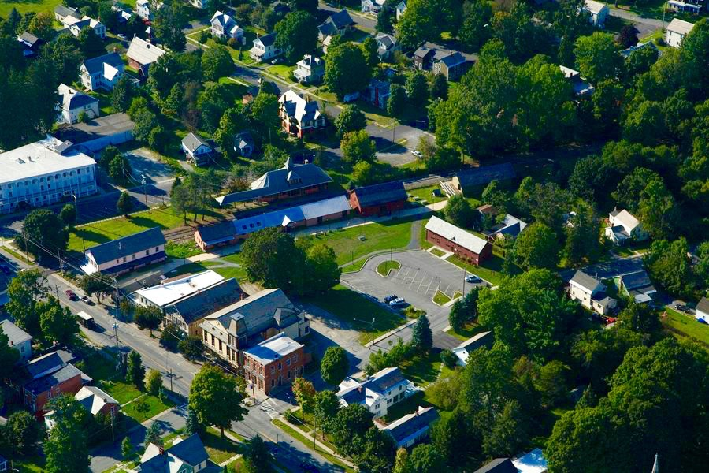
Hubbard Hall Campus

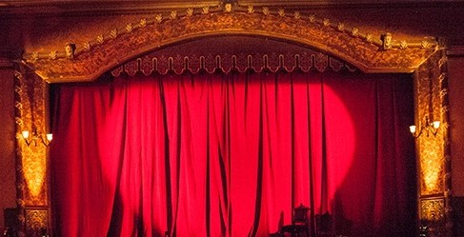
Front of Main Stage

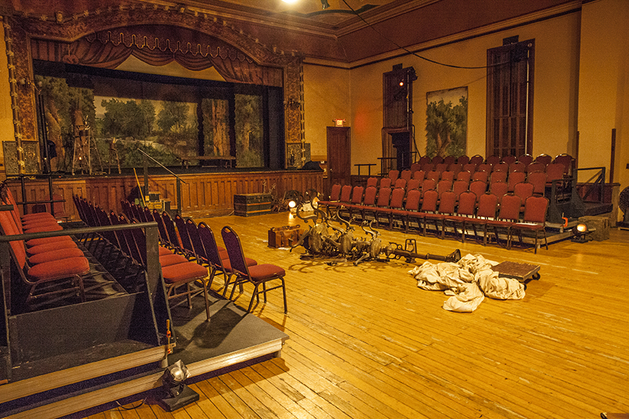
Main Stage in Tech (seating completely flexible)

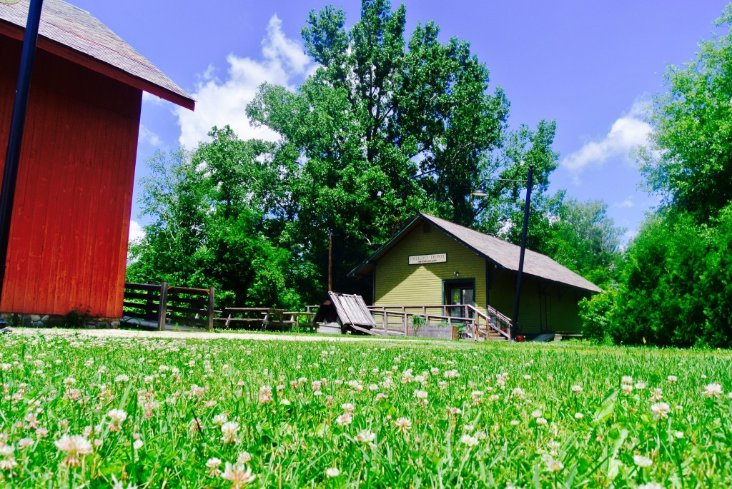
Freight Depot Black Box and Quebecois bread oven

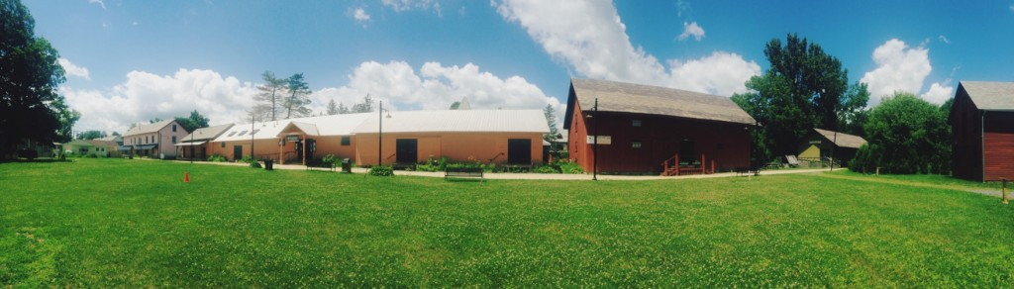
Hubbard Hall Visual Arts, Dance Studio, Future Artist Housing and Mixed-Use Spaces

